PROGRAMME: BSSE/BSCS/BIT
YEAR/SEM: YEAR 2 SEM 1
COURSE CODE:BIT2115
PROBLEM NAME: JAVA VARIABLE TYPES

STUDENT DETAILS:
NAME OF STUDENT | DURETI EDAO OBSE
REG NUMBER | 25/1707/BSCS-S

Section 1
Logic Building & Programming
Lines of code & explanations
Line Number | Explanation
1 | Declares a public class named Course
2 | Opens the course class body
3 | Declares an instance variables courseName
4 | Declares an instance variables numberOfStudents
5 | Declares a static variabletotalStudents and initializes it to 0
7 | Declares constructors courseName and numberOfstudents
8 | Opens the constructor body
9 | Assigns incoming parameter to instance field courseName
10 | Assigns incoming parameter to instance field numberOfstudents
12 | Updates the current courses to the shared static
13 | Closes the constructor body
14 | Declares an instance method with no return value to display course metrics
15 | Opens the showStatistics method body
16 | Declares and initializes a local variable for pass rate.
18 | Prints the string Course to the console
19 | Prints Number of students to the console
20 | Prints Pass percentage to the console
21 | Opens the showStatistics method body
22 | Declares the application execution entry point method.
23 | Opens the beginning of the main method
24-28 | Initializes a new course object for the course with number of students
30-32 | Calls showStatistics on each course object, printing its specific details
34 | Prints the static cumulative student total
35 | Close the main method body
36 | Close the Course class body

Detailed Screenshots and caption descriptions 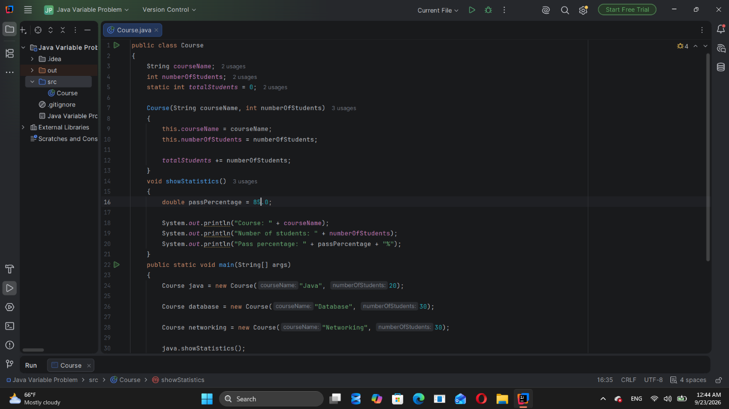

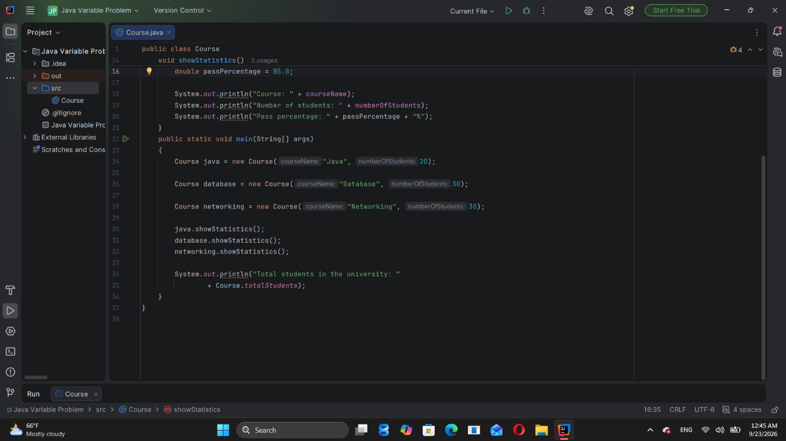
Figure 1:Class Main showing project structure

Output and caption descriptions
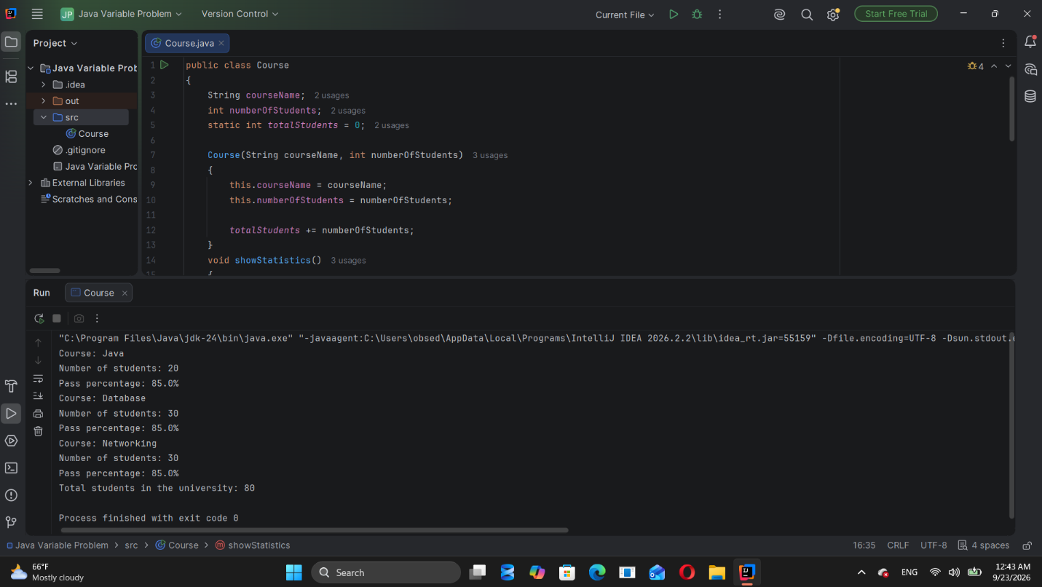
Figure 2: Output after running the program

Output Explanation
From the output provided above, when the program is executed, it will display the
output as seen above.

Section 2
Version Control
Repository Overview
Repository Name
Repository URL
Branches

